
A PROJECT REPORT
ON

Hospital Management System

SUBMITTED BY

Ms. NANDA ANCHAL VIMAL
ACADEMIC YEAR 2025-26
M.S.C IT SEM 3

UNDER THE GUIDANCE OF

Mr. Shaunak Purohit

SMT.C.Z.M. GOSRANI BCA & M.SC. (IT & CA)
College JAMNAGAR SUBMITTEDTO

SAURASHTRAUNIVERSITY-RAJKOT

A PROJECTREPORT ON

Hospital Management System

SUBMITTEDBY

Ms. NANDA ANCHAL VIMAL

ACADEMIC YEAR 2025-26
M.S.C IT SEM 3

UNDERTHEGUIDANCEOF

Mr. Shaunak Purohit

SMT.C.Z.M.GOSRANIBCA & M.SC. (IT & CA)COLLEGE JAMNAGAR

SUBMITTED TO


SAURASHTRAUNIVERSITY-RAJKOT



ABSTRACT

The Hospital Management System (Health-Connect) is a modern, web-based application designed to simplify hospital operations. With increasing demand for digital health solutions, this platform offers a convenient way for patients to book appointments, doctors to manage their schedules, and pharmacies to handle medicine requests.
The system provides a user-friendly interface featuring detailed doctor profiles, pharmacy listings with medicine catalogs, and a comprehensive admin dashboard. It ensures an effortless experience for all user roles: Patients, Doctors, and Admin.
This platform is built with a strong backend architecture (Node.js/Express) and a responsive frontend (React), connected by a reliable PostgreSQL database. It features secure authentication, real-time data updates, and efficient workflow management.
Overall, Health-Connect bridges the gap between traditional healthcare services and digital accessibility, offering a faster, safer way to manage health needs. It provides a foundation for future enhancements such as AI diagnosis and mobile app integration.

ACKNOWLEDGEMENT

We feel great pleasure in submitting this project report as a part of Our M.S.C Semester 3 curriculum. A practical study plays an important role.
For the successful completion of Our project, We would especially like to thank my parents for their support and unconditional help. We would also like to thank Our Project Guide Khushal Rajani for their constant support and help in implementation of this project.
We are also thankful to our Principal Mam, Ms. Hetal G. Savla for all the facilities they provided throughout our semester.
Lastly, We would also like to thank the faculties and staff members of Smt. C.Z.M. Gosrani B.C.A. College, Jamnagar.

PROJECT PROFILE

STUDENTINFORMATION
Name  NANDA ANCHAL VIMAL | Enrollment Numbers  24CS032PG00105
PROJECTDETAILS
Project Title | Hospital Management System
Duration | 4 Months
Name of Project | Hospital Management System
Platform | Express and React.js
Team Size | 1
GUIDEINFORMATION
Name of Guide | Mr. Shaunak Purohit

INDEX

Chapter | Title | PageNo.
1 | Overview of the accepted SDLC Model | 01
2 | System Analysis | 02
 | 2.1 Problem Statement | 02
 | 2.2 Proposed Solution | 02
 | 2.3 Scope of the System | 03
3 | System Design | 04
 | 3.1 Use Case Diagram | 04
 | 3.2 Data Flow Diagrams (DFD) | 08
 | 3.3 ER Diagram | 10
 | 3.4 Gantt Chart | 11
4 | Implementation | 14
 | 4.1 Tech Stack | 14
 | 4.2 Database Schema | 19
 | 4.3 Data Dictionary
 | 4.4 Data Flow Diagram (DFD)
 | 4.5 ER Diagram
 | 4.6 Use Case Diagram
 | 4.7 Use Case Diagram
5 | Test Cases | 31
6 | Screenshots | 34
7 | Limitations and Future Enhancements | 45
8 | Conclusion | 46
9 | References AND Bibliography | 47

CHAPTER1

INTRODUCTION

The healthcare industry relies heavily on efficient information management to ensure smooth operations and high-quality patient care. Health-Connect is a comprehensive web application specifically designed to address the complexities associated with hospital administration, doctor scheduling, and pharmacy management. Unlike traditional healthcare systems, which often operate in isolated silos, Health-Connect integrates all these functionalities into a single, unified platform. This allows patients to access a wide range of services remotely, including appointment booking, medicine ordering, and real-time updates on hospital facilities. By centralizing information, the system ensures data consistency across all modules, significantly reduces manual errors, and streamlines administrative processes. Moreover, it enhances the overall patient experience by providing timely notifications, easy access to medical records, and a user-friendly interface, ultimately contributing to more efficient hospital operations and improved healthcare delivery.

OVERVIEWOFTHEACCCEPTEDSDLCMODEL

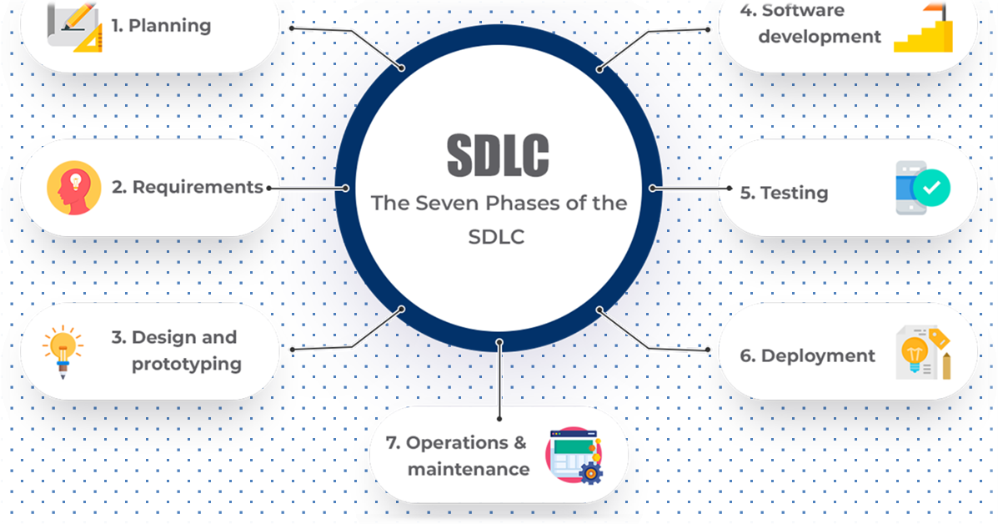

The Software Development Life Cycle(SDLC)involves the following key phases:
- Planning and requirement: Define project goals, requirements, and timelines.
- Design: Create system architecture, database schema, and UI designs.
- Development: Write code, implement features, and integrate technologies.
- Testing: Thoroughly test the system for bugs and functionality.
- Deployment: Prepare and deploy the PMS on a web server.
- Maintenance: Provide on going support and address feedback for improvements.

CHAPTER 2

SYSTEM ANALYSIS

2.1 Problem Statement

Manual record keeping in hospitals is prone to errors, such as misplacement of patient records, incorrect data entry, and delays in retrieving critical medical information.

Patients often face long waiting times for appointments, leading to dissatisfaction and increased administrative workload.

Pharmacy stock is frequently not visible to patients online, making it difficult to check the availability of medicines in advance.

Lack of integration between hospital departments causes inefficiencies and delays in patient care.

Reliance on traditional methods increases operational costs and reduces overall effectiveness of hospital management.

2.2 Proposed Solution

Develop a centralized web portal that integrates all hospital services for patients, doctors, and administrators.

- Enable real-time appointment booking, allowing patients to schedule appointments online and track their status without long waiting times.
- Integrate a pharmacy module that allows patients to request medicines and check availability online.
- Automate administrative processes to reduce manual errors and improve data consistency across all departments.
- Provide a unified platform that streamlines hospital operations and enhances patient experience.

2.3 Scope of the System
- User Authentication: Secure login for Patients, Doctors, and Admins with role-based access.

- Doctor Management & Appointment Scheduling: Admins can manage doctor profiles and schedules; patients can book and track appointments in real time.

- Pharmacy Inventory & Request Management: Track medicine stock, handle patient requests, and process orders efficiently.

- Data Management: Maintain patient records, appointment history, and medicine requests in a centralized database.

- Reporting & Monitoring: Admins can monitor appointments, pharmacy stock, and system usage to ensure smooth hospital operations.

CHAPTER 3

SYSTEM DESIGN

3.1 Use Case Diagram

The use case diagram of the Health-Connect Hospital Management System represents the interactions between the system and its primary users. The system involves three main actors: Patient, Doctor, and Admin.

Patient: The patient can perform actions such as logging into the system, booking appointments with doctors, and ordering medicines online through the pharmacy module.

Doctor: Doctors have access to their personal dashboard, where they can view upcoming appointments, manage patient information, and update their professional profile.

Admin: The admin is responsible for managing overall hospital operations, including adding or updating doctor details, managing pharmacies and medicine inventory, and handling patient or doctor requests efficiently.

This use case diagram provides a clear visualization of system functionalities and ensures that all interactions are accounted for in the system design.

3.2 Data Flow Diagrams (DFD)

Context Level (Level 0):
At the highest level, the system receives inputs from users and interacts with the central database. Users include patients, doctors, and administrators. All requests and data flow from the user interface to the system, which processes the requests and stores relevant information in the database.

Level 1:

Authentication Process: Users first access the system via the login module. The authentication process verifies credentials before granting access.

Dashboard Access: After successful login, users are directed to their respective dashboards.

Appointment Processing: Patients can schedule appointments, which are recorded in the database, while doctors and admins can view and manage these appointments.

Medicine and Request Processing: Users can request medicines, and the system ensures that the pharmacy and admin receive and process these requests.

The DFD ensures that data flow between users, processes, and the database is seamless and accurately represents how information is managed throughout the system.

3.3 ER Diagram

The Entity-Relationship (ER) Diagram describes the database structure and relationships between entities within the system. Key entities include:

Users: Represents all patients, doctors, and admins.

Doctors: Contains professional details of doctors, linked to users.

Appointments: Stores appointment information between patients and doctors.

Pharmacies: Represents pharmacy information and associated medicines.

Medicines: Contains medicine details such as name, quantity, and price.

Requests: Tracks medicine requests and approvals by the admin.

Relationships:

Each user is associated with a single doctor (1:1) where applicable.

Each doctor can have multiple appointments (1:N).

Each pharmacy manages multiple medicines (1:N).

The ER diagram ensures that the database is well-structured, minimizing redundancy and ensuring efficient data retrieval.

3.4 Gantt Chart

The project development schedule is planned over four months and represented in the Gantt chart as follows:

Month 1: Requirement analysis and database design are completed, ensuring a solid foundation for system development.

Month 2: Backend API development is performed, including modules for authentication, doctor management, and request handling.

Month 3: Frontend development is carried out alongside the pharmacy module, integrating the user interface with backend functionality.

Month 4: System integration, testing, and documentation are completed to ensure a fully functional and reliable Health-Connect Hospital Management System.

The Gantt chart helps in monitoring project progress and ensures that all development stages are completed within the allocated timeline.

CHAPTER4
SYSTEM ANALYSIS AND MODELING

4.1 Tech Stack
The Health-Connect Hospital Management System is implemented using modern and efficient technologies to ensure scalability, performance, and ease of use:
- Frontend: React.js for dynamic and responsive user interfaces, along with Tailwind CSS for styling.
- Backend: Node.js with Express.js framework to handle server-side logic and API development.
- Database: PostgreSQL, a robust relational database system, managed using Drizzle ORM for object-relational mapping and efficient database operations.
- Additional Tools: Git for version control, Postman for API testing, and Visual Studio Code as the primary development environment.

4.2 Database Schema
The database schema is designed to efficiently handle all hospital operations including user management, doctor scheduling, appointments, pharmacy management, and payments. Key tables and their details are as follows:
Column | Data Type | Constraints
ID | Int(11) | Primary Key, Auto Increment
Username | Varchar(255) | NOT NULL
Password | Varchar(255) | NOT NULL
Role | Varchar(50) | NOT NULL (Patient / Doctor / Admin)
Table:Doctor
ID | Int(11) | Primary Key, Auto Increment
Name | Varchar(255) | NOT NULL
Email | Varchar(255) | NOT NULL, Unique
Specialization | Varchar(255) | NOT NULL
Phone | Varchar(20) | NOT NULL

Table: Appointments
Column | Data Type | Constraints
ID | Int(11) | Primary Key, Auto Increment
PatientID | Int(11) | Foreign Key (Users)
DoctorID | Int(11) | Foreign Key (Doctors)
Date | Date | NOT NULL
Time | Time | NOT NULL
Status | Varchar(50) | NOT NULL (Pending / Confirmed / Completed)

Table: Pharmacy
Column | Data Type | Constraints
ID | Int(11) | Primary Key, Auto Increment
MedicineName | Varchar(255) | NOT NULL
Description | Varchar(500) | NOT NULL
Price | Int(11) | NOT NULL
Stock | Int(11) | NOT NULL

Table: Requests
Column | Data Type | Constraints
ID | Int(11) | Primary Key, Auto Increment
PatientID | Int(11) | Foreign Key (Users)
MedicineID | Int(11) | Foreign Key (Pharmacy)
Quantity | Int(11) | NOT NULL
Status | Varchar(50) | NOT NULL (Pending / Approved / Rejected)

Table: Payments
Column | Data Type | Constraints
ID | Int(11) | Primary Key, Auto Increment
OrderID | Int(11) | Foreign Key (Appointments / Requests)
Amount | Int(11) | NOT NULL
Status | Varchar(50) | NOT NULL (Pending / Completed / Failed)

4.3 Data Dictionary
Users Table: Stores details of all users including patients, doctors, and admins.
Doctors Table: Stores professional details of doctors and their specialization.
Appointments Table: Tracks patient appointments with assigned doctors along with status.
Pharmacy Table: Maintains medicine inventory including name, description, price, and stock.
Requests Table: Manages patient requests for medicines including approval status.
Payments Table: Tracks all payments for appointments and medicine orders, ensuring accurate billing.

4.4 Data Flow Diagram (DFD)
Context Level:
- Users (Patients / Doctors / Admin) interact with the system.
- System communicates with the database to fetch or store data.
Level 1:
- Patients log in → Schedule appointments → Data stored in Appointments table.
- Patients request medicines → Requests table updated → Admin/Pharmacy approves.
- Doctors view appointments and update statuses → System updates database.
Level 2:
- Payments processed online → Payment status updated.
- Admin monitors all operations → Generates reports for management.

4.5 ER Diagram
- Entities: Users, Doctors, Appointments, Pharmacy, Requests, Payments
- Relationships:
  - Users (1:N) Appointments
  - Doctors (1:N) Appointments
  - Users (1:N) Requests
  - Pharmacy (1:N) Requests
  - Requests (1:1) Payments
4.6 Use Case Diagram
Actors:
- Patient: Register, Login, Book Appointment, Request Medicines, Make Payment.
- Doctor: Login, View Appointments, Update Status.
- Admin: Manage Doctors, Monitor Appointments, Approve Medicine Requests, Manage Payments.

4.7 Gantt Chart
Month | Activities
Month 1 | Requirement Analysis, Tech Stack Setup, Database Design
Month 2 | Backend API Development (Auth, Users, Doctors, Appointments)
Month 3 | Frontend Development, Pharmacy & Request Modules
Month 4 | Integration, Testing, Documentation, Final Deployment
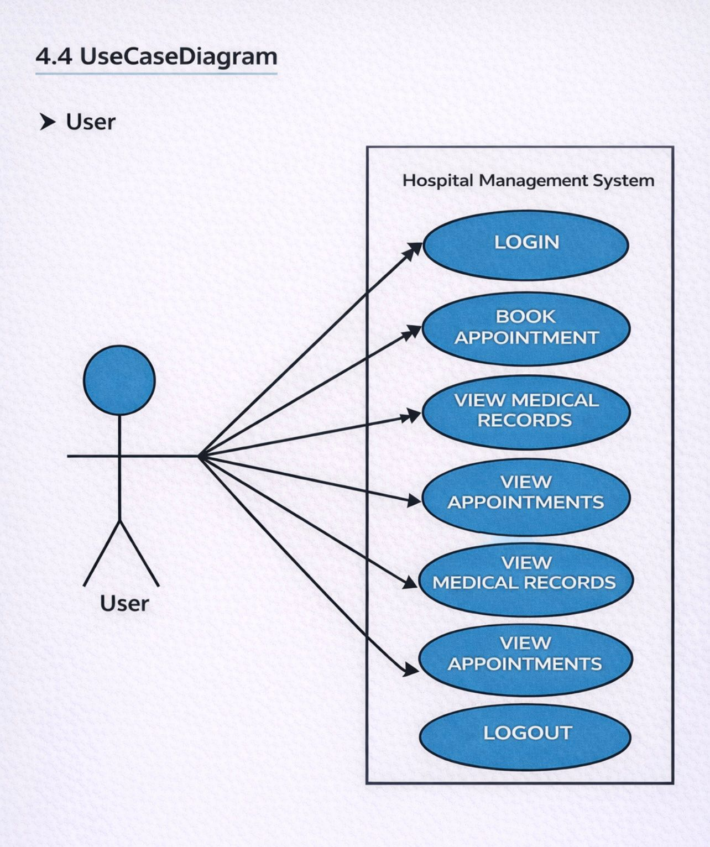

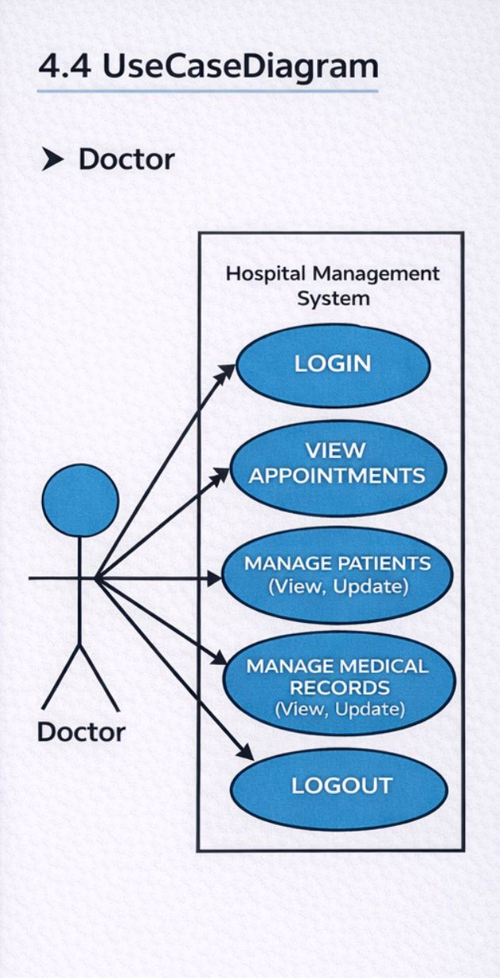

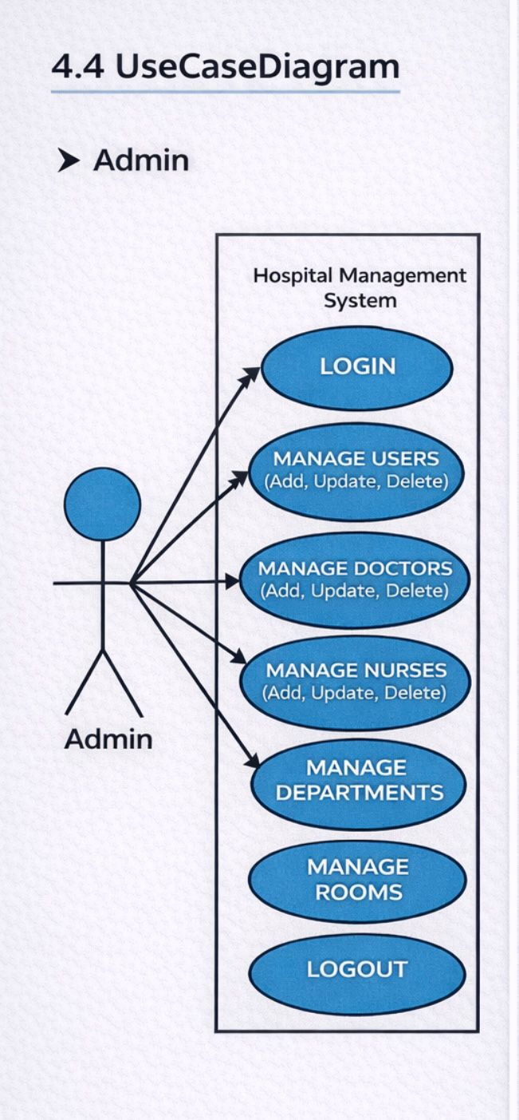
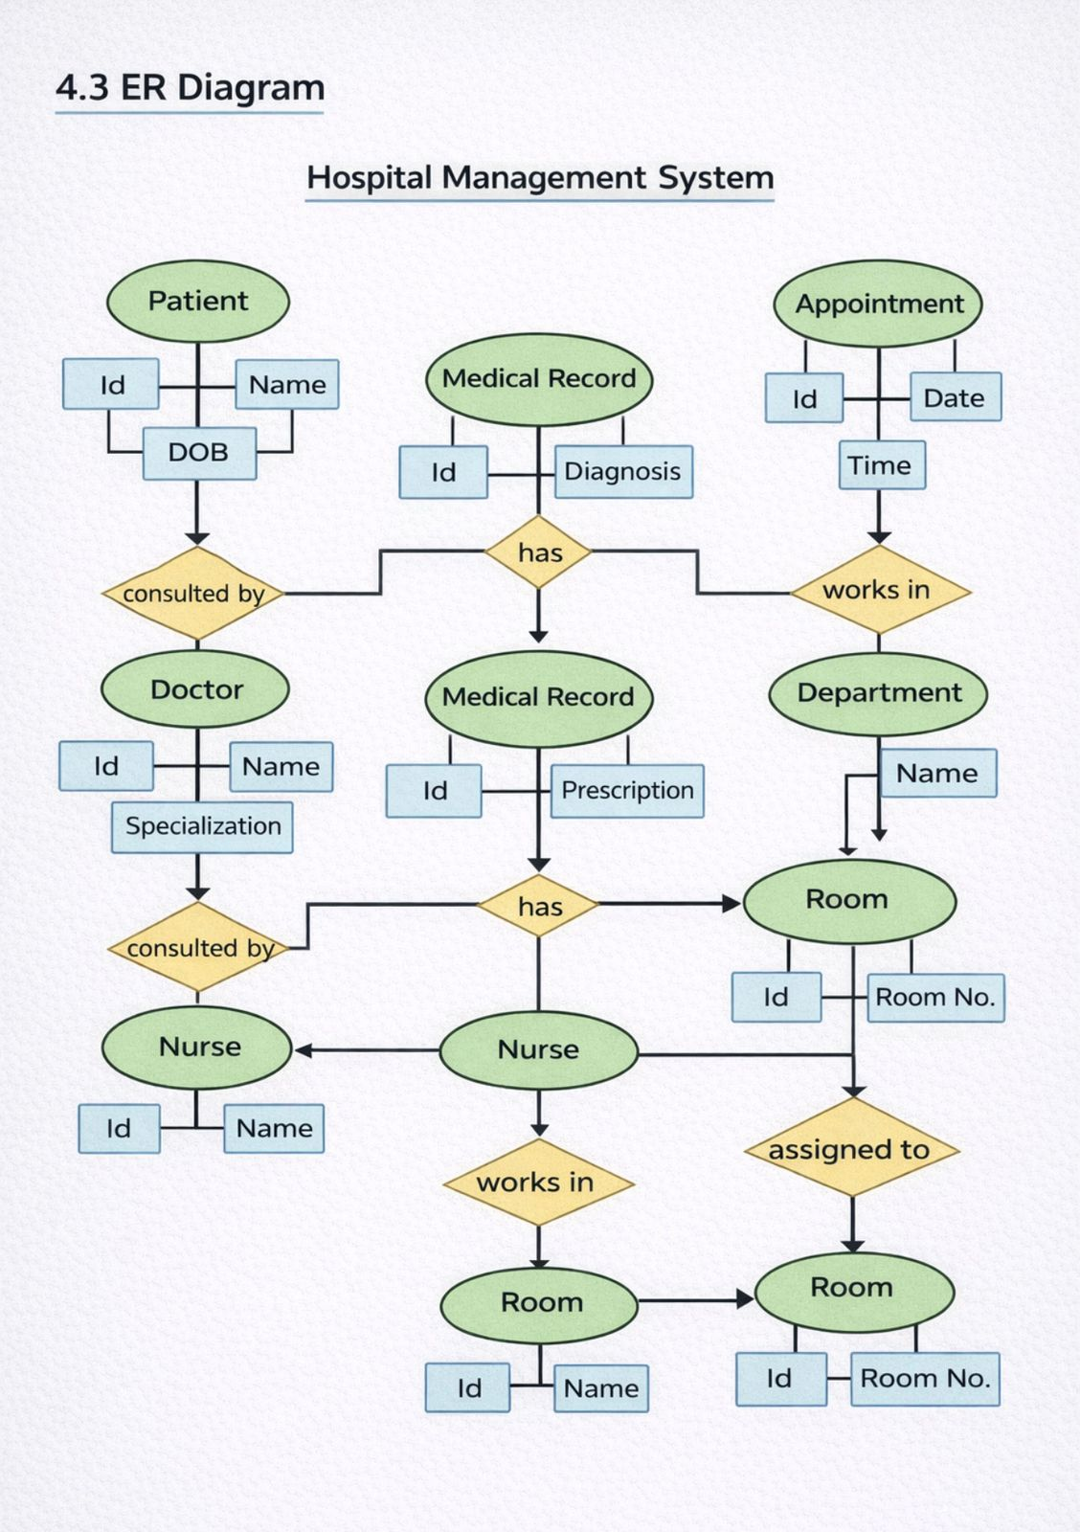

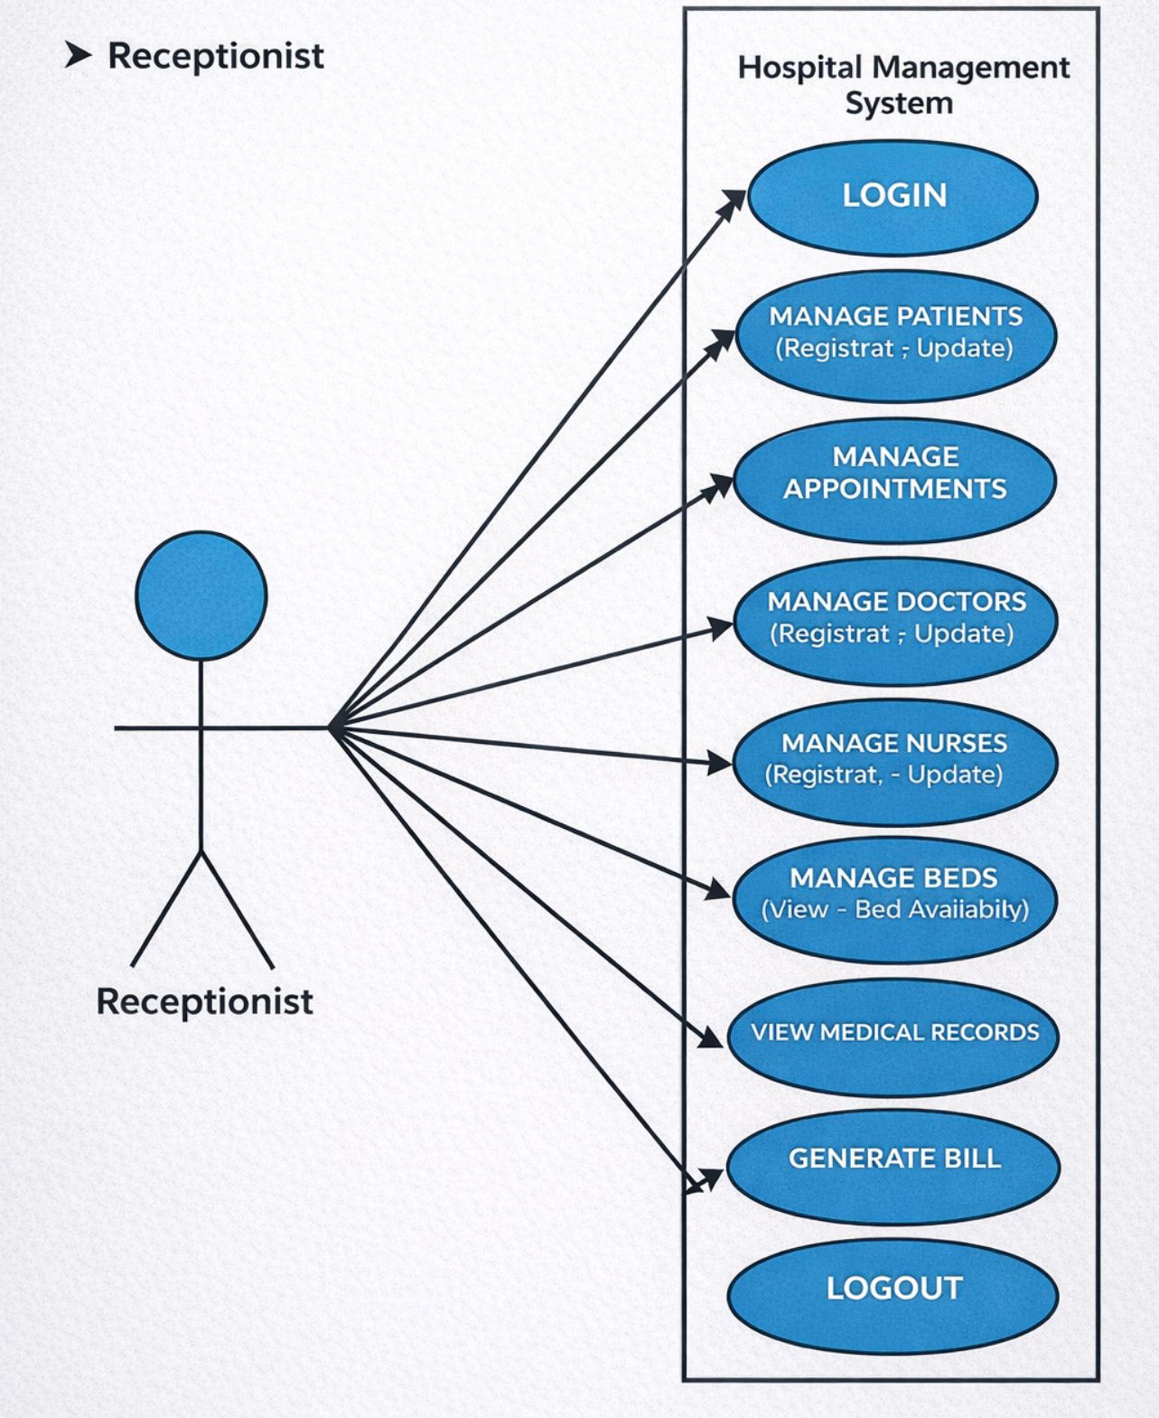
––

CHAPTER5
Test Cases

Test Case 1: Login Module

Step No. | Test Data / Action | Expected Result | Status
1 | Enter valid admin credentials | Login successfully | PASS
2 | Enter invalid credentials | Error message displayed | PASS

Test Case 2: Medicine Request

Step No. | Test Data / Action | Expected Result | Status
1 | Select medicine name (e.g., Paracetamol) | Medicine selection form opens | PASS
2 | Enter required details (quantity, notes) | Data accepted successfully | PASS

Test Case 3: Appointment Booking Module

Step No. | Test Data / Action | Expected Result | Status
1 | Select doctor and date | Appointment form opens | PASS
2 | Confirm appointment | Appointment booked successfully | PASS

Test Case 4 Pharmacy Management Module

Step No. | Test Data / Action | Expected Result | Status
1 | Add medicine details | Medicine added to system | PASS
2 | Update stock quantity | Stock updated successfully | PASS

Test Case 5 Payment Module

Step No. | Test Data / Action | Expected Result | Status
1 | Select online payment option | Payment gateway page opens | PASS
2 | Complete payment | Payment processed successfully | PASS

CHAPTER6

Screenshots

Home Page

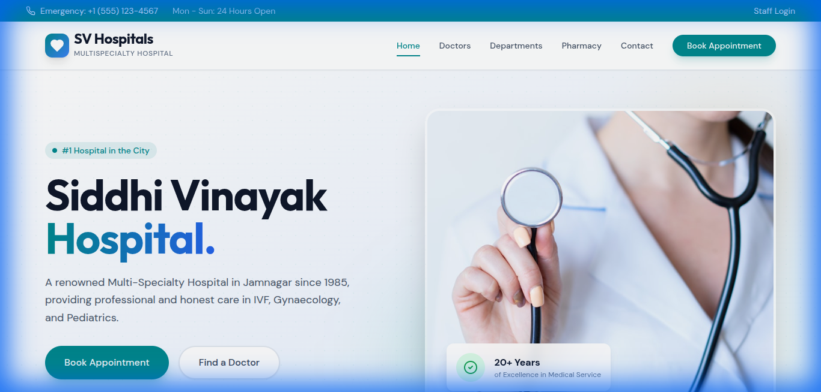

Description: The landing page allowing users to access services.

Admin Login
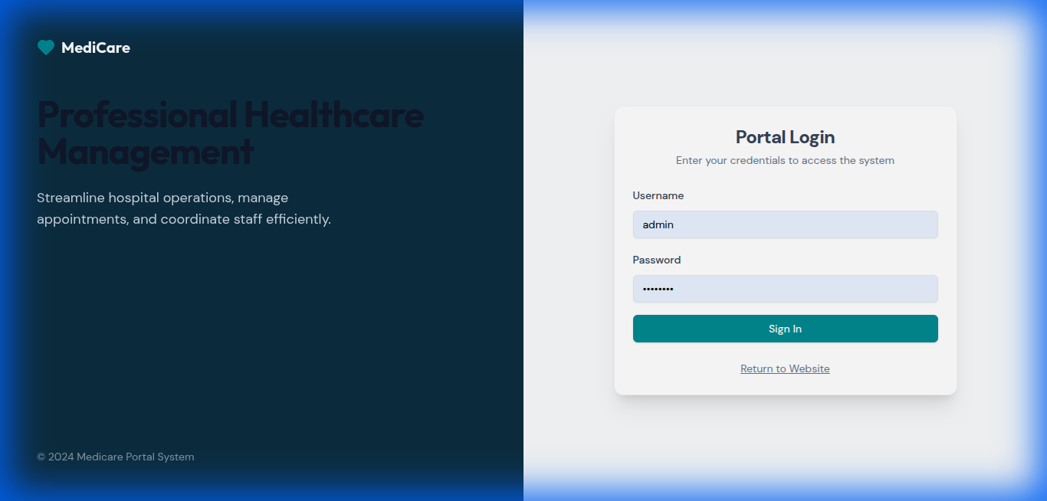

Description: Secure login page for administrators.

Admin Dashboard
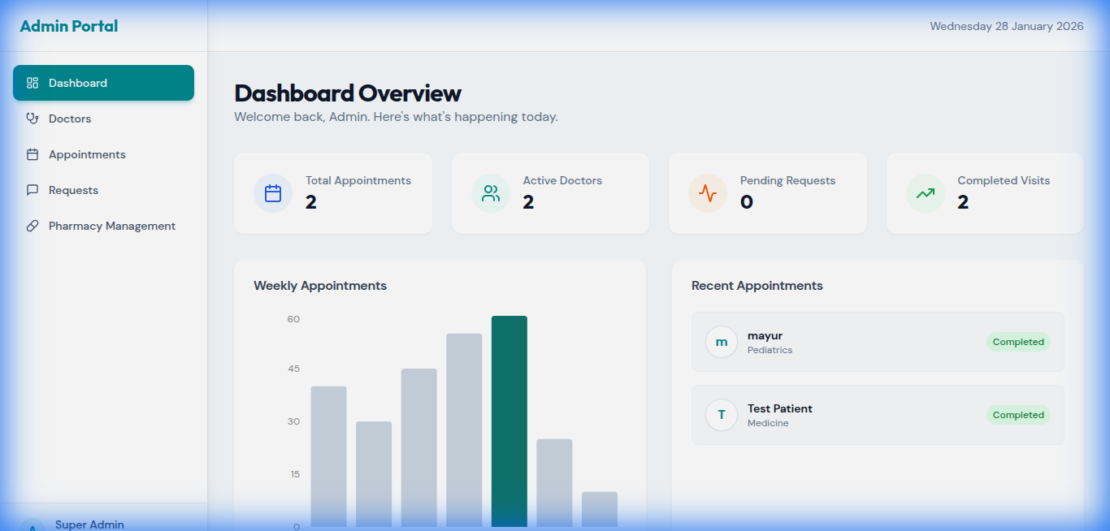

Description: Dashboard showing hospital overview.

Pharmacy List
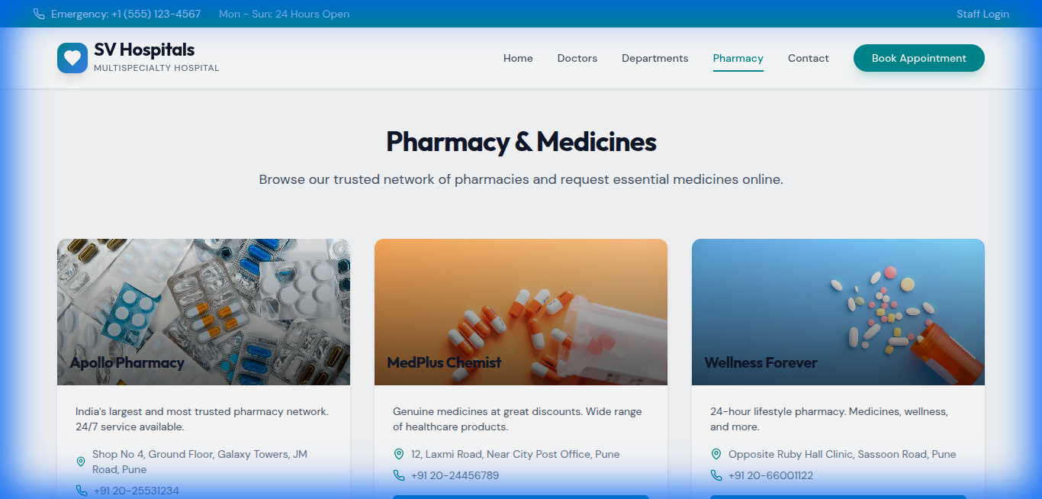

Description: Users can browse available pharmacies.

Pharmacy Details

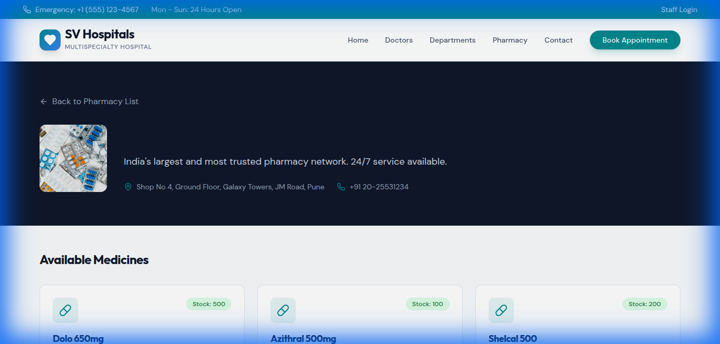

Description: Viewing medicines stocked by a specific pharmacy.

Admin Pharmacy Management
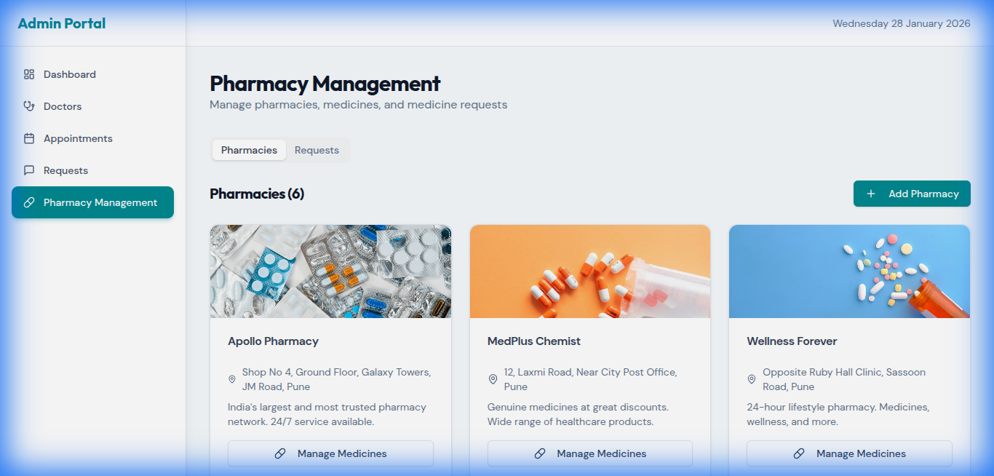

Description: Admin interface to manage inventory and requests.

CHAPTER 7

LIMITATIONS AND FUTURE ENHANCEMENTS

Limitations:

Despite offering various useful features, the Hospital Management System has certain limitations. One of the major limitations is that the system requires a stable and active internet connection to function properly. In situations where internet connectivity is weak or unavailable, users may face difficulties in accessing patient records, appointment scheduling, and other hospital services. This dependency on internet connectivity can affect the smooth operation of the system, especially in remote or rural areas. Another limitation of the system is the absence of an online payment gateway. Currently, patients are unable to make payments through digital modes such as credit cards, debit cards, or online wallets within the system. As a result, billing and payment processes need to be managed manually or through offline methods, which may increase workload and reduce overall efficiency.

Future Enhancements:
To overcome the existing limitations and enhance system performance, several future improvements have been proposed. One important enhancement is the development of a mobile application for both Android and iOS platforms. This mobile application would allow patients, doctors, and hospital staff to access the system anytime and anywhere using their smartphones, making hospital services more convenient and user-friendly. Another significant enhancement is the integration of an AI-based symptom checker. This feature would assist patients by analyzing their symptoms and providing preliminary medical suggestions, helping them decide whether immediate medical attention is required. Additionally, integration with insurance providers is planned as a future enhancement. This integration would enable cashless treatment facilities and streamline the insurance claim process, reducing paperwork and improving transparency between hospitals, patients, and insurance companies.

CHAPTER 8

Conclusion

The Health-Connect Hospital Management System provides a comprehensive, efficient, and user-friendly platform for managing healthcare services in a digital environment. The system is designed to simplify essential hospital operations such as appointment scheduling, pharmacy management, and patient record handling, making the overall healthcare process more organized and accessible. It allows patients to easily book appointments, access pharmacy services, and manage their healthcare information online, reducing the need for manual processes. At the same time, the system offers robust and secure tools for administrators to efficiently manage hospital resources, staff, and data. Overall, this project demonstrates an effective and reliable solution for modern digital healthcare, improving operational efficiency, enhancing patient experience, and supporting the growing demand for technology-driven healthcare services.

CHAPTER9

References and Bibliography

All the references listed below were used to develop and design this website and were also used for documentation. Weare thankful to each and every person who helped us and supported us for this project completion.

- Books:-
  - Chaffey, Dave

  - Krug, Steve

Libraries and Server:-

  - Angular AND React.js

Websites:-
- React Documentation - https://react.dev/
- Express.js Guide - https://expressjs.com/
- PostgreSQL Documentation - https://www.postgresql.org/
- Tailwind CSS - https://tailwindcss.com/

